**BlackHawk Automation**

[Get BlackBox](https://www.buymeacoffee.com/calibluesea/e/175942)

[github.com/KaiKai7/BlackBox](http://github.com/KaiKai7/BlackBox)

BlackBox Security Sensor

September 04, 2023

# Product Overview



The BlackBox is a portable vibration sensor that can send notifications via Telegram Messenger. The connection is made using a wifi connection. Using any browser while on the same network as the BlackBox, the credentials for the wifi network as well as Telegram are entered during the one time setup. Nothing other than Telegram needs to be installed and Telegram can also be accessed on the web here [www.telegram.org](http://www.telegram.org).

The BlackBox was intended to secure areas that are not currently monitored as this is an easy way to do so. It is not intended to replace any alarm system but rather work in conjunction with. It is also not a tracker, there are robust options already available. It is meant to fill the gaps left by traditional alarm devices with no monthly fees.

If you choose to take the Black Box to another location outside of the range it was originally programmed in - it will enter the setup mode again after 3 minutes. This will allow a new wifi network to be entered or a change in the Telegram credentials from what was previously entered.

## Credentials Needed For The BlackBox -Setup Portal

The BlackBox-Setup portal is the page where the credentials to connect to the BlackBox are entered. If successful this only needs to be done once.

Here is what we will need to complete the setup :

(a) **Wifi SSID** - This is the name of the wifi network that we want the BlackBox to connect to.

(b) **Password** - This is your wifi password for the network (ssid) above. If you don't remember the password, look on the side of your router. If you did not change it from the default then the password you see is most likely the one we want.

(c) **Telegram Bot Token** - This is the token that we got from the BotFather. This identifies you to Telegram and is unique to you.

(d) **Chat ID** - This is the chat id we got from the myidbot. This is also unique to you.

(e) **BlackBox Name** - Choose a name for your BlackBox. This will help identify exactly where or what the purpose of this BlackBox is. It will also help to distinguish from another BlackBox if more than one is used.

(f) **Alarm Message** - Here you can accurately describe the alarm notification that you will see when triggered. You are not limited to prepopulated names that do not match any alarm you may be having. This creates a more natural response to an alarm. The message becomes whatever you made it say.

(g) **Internal Vibration Sensor** - This field is to program the BlackBox to start up and run with either the internal vibration sensor enabled or disabled. Set to “1” and the internal vibration sensor is active. Set to “0” and it is off. By default the sensor is set to “1” On.

This means you can operate the BlackBox with an external sensor connected and configure it many ways. And it also means that a dedicated button was not necessary in order to select.

For example, if you want to connect an external sensor and then put the BlackBox somewhere where it may be moved or bumped but you don't want a false alarm on the internal vibration sensor. Or maybe you want to activate both at the same time. To activate the external sensor all you have to do is simply plug it in.

* Internal Vibration Sensor only mode
* External Sensor only mode (simply plugging in external sensor activates, unplugging deactivates)
* Both Sensors at the same time

### Getting to the BlackBox-Setup Portal

Open wifi settings and search for available wifi networks. BlackBox-Setup should be listed as one of the wifi networks that you can select. Once BlackBox-Setup is selected there is a password. This is just for the setup portal and it is only active when there is no connection available.

The password is “password” without the quotes.

This example is shown for Android devices but the process is similar for all platforms.

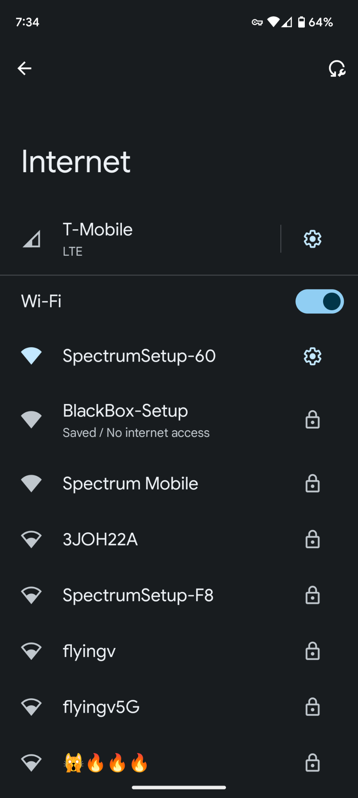

Once BlackBox-Setup is selected the WifiManager screen is next. Choose Configure Wifi.

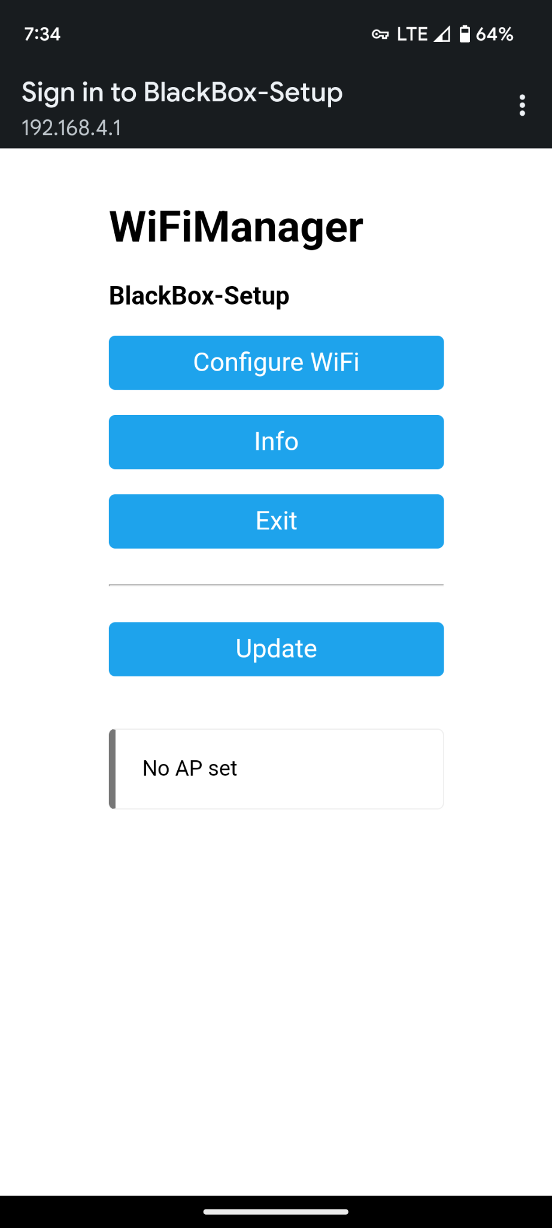

Now select your SSID from the list of available wifi networks.

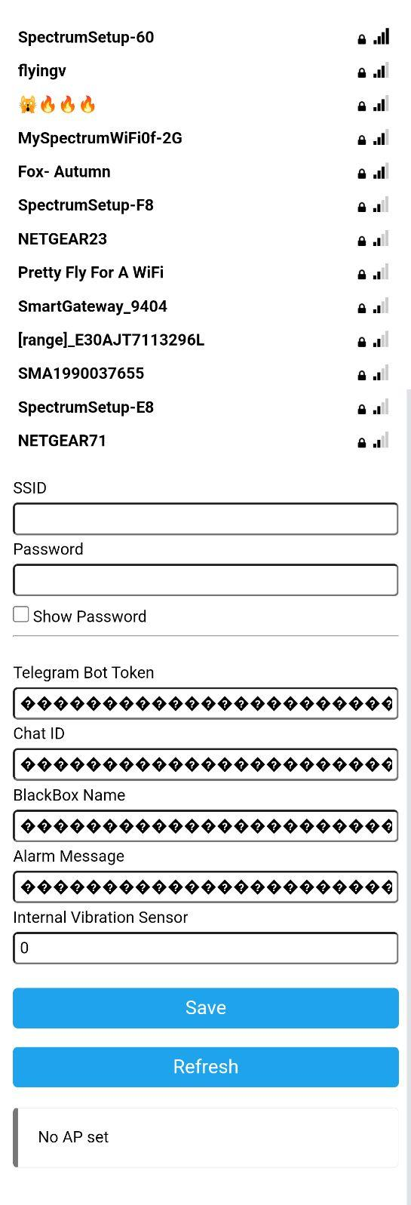

Next is the **Bot Token**. Enter your Bot Token that was received from the Botfather earlier.

Then enter the **Chat ID** received from the MyIdBot.

Now we enter the **BlackBox Name.** The name helps to distinguish one BlackBox from another if multiples are used. It also provides a more detailed notification.

**Alarm Message**. Here the notification is specified. This can be a s specific as you wish. So for example, instead of “Room 1” you could make it “Mike’s Laboratory” or whatever you want. Again this makes for a more detailed notification. It also makes the notification personal to you and stands out when received.

**Internal Vibration Sensor**. This determines whether the internal vibration sensor is active. The reason for this is the **external sensor port**. This port lets any two wire dry contact be made in addition to the internal vibration sensor. And although you may want both to be active there may be times where you only want one active. This gives complete control.

It must be set to 1 for the internal vibration sensor to be on. And set to 0 if off is desired. The external sensor is active whenever a sensor is plugged in.

## Save Changes

Some fields have strange characters filled in when you first visit the portal. This is to obfuscate the information that was previously filled in. Always delete it from the field before entering new info in case it was incorrectly entered previously.

Once saved the connection to the portal will drop as the BlackBox will now use the new credentials entered to connect to wifi and send you a successful connection notification. This is done using the info you just saved to the BlackBox. So if after saving to the BlackBox you do not receive a Telegram notification then something was not configured correctly. If this is the case then go back to wifi settings and repeat the process after connecting to BlackBox-Setup.

Upon a successful connection to wifi and Telegram there will be a notification. This notification will include the connected ip address of the BlackBox, the ssid that the BlackBox is connected to and an example of the message that will be received if triggered.

At this point the BlackBox is set and monitored using the sensors you specified.

You can change the **default notification sound in Telegram** to give the alarm a sound tailored to exactly what you are trying to achieve. Also overriding **Do Not Disturb mode** is a good idea as well to make sure you receive notifications.

There is no limit to where you can put a BlackBox as long as it has access to wifi to report alarm notifications and can be powered.

If using outdoors keep in mind that the BlackBox itself is **not waterproof** but can be used in a non metallic case to protect from the elements.

The BlackBox is powered by 5v dc power and any 5v battery or battery pack will power the BlackBox. Average power consumption during use is 75mah. The BlackBox should run at least 12 hours on the built in rechargeable 18650 battery.

### Some examples for use :

Cars

Boats

Motorcycles

Bicycles

RV’s

Trucks

Doors

Windows

Storage Units

Lockers

Dog Doors

Camping

Tents

Scooters

Purses

Alcohol Cabinet

Prescription Drug Cabinet

Cabins

Hotels

Desk Drawers

Gates

Garage Door